12.54
a)
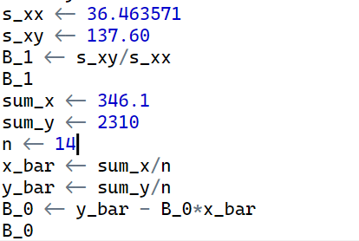
$${\hat{β}}_{1}= 3.773629$$

$${\hat{β}}_{0}= 71.71049$$
Interpret: In average, the ulna length increases 1 cm lead the height of patient increases 3.773629 cm

b)
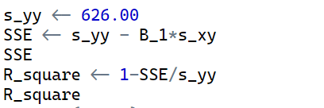
Coefficient of determination = 0.8294751
Interpret: 82.95% the variation in observed height of patient can be explained by the model fitted to the data

c)
H0: ${\hat{β}}_{1}=0$
H1: ${\hat{β}}_{1}≠0$
When H0 is true:
t-value = 7.64 and p-value = 6.00e-06 -> Reject H0 for any significance level. Therefore, the model is meaningful. Moreover, the coefficient of determination = 0.8294751, quite large. So the model is useful to predict the height of patient.

d)
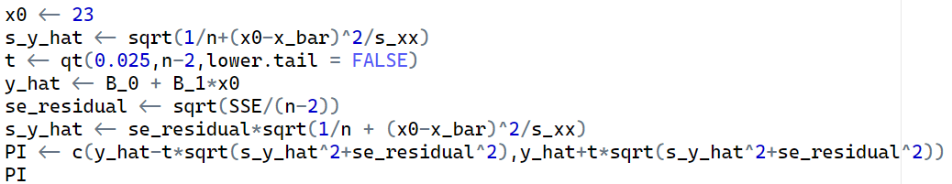

95% PI for the height of individual whose ulna length are 23 is: (151.527;165.481)

95% PI for the height of individual whose ulna length are 25 is: (159.3180;172.7844)

e) The 95% PIs for heights at ulna length = 23 cm and 25 cm overlap, suggesting that height can’t be predicted quite as precisely as we might like

Exercise 13.43
a)
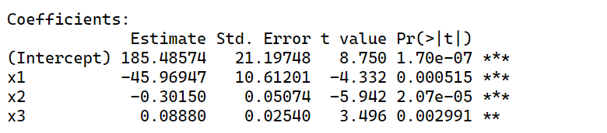
From this table we have:
-${\hat{β}}_{0}=185.48574$
-${\hat{β}}_{1}=-45.96947$
-${\hat{β}}_{2}=-0.30150$
-${\hat{β}}_{3}=0.08880$
The least square line: $\hat{y}=185.48574-45.96947x1-0.30150x2+0.08880x3$
With x1 = 2.6, x2 = 250, x3 = x1*x2 = 650:$\hat{y}=48.310$

b)
No, it is not legitimate to interpret ${\hat{β}}_{1}$in this way. It is not possible to increase the cobalt content (x1) while keeping the interaction predictor (x3) fixed. When x1 changes, so does x3, since x3 = x1x2.

c)
Fisher -test
H0: ${\hat{β}}_{1}={\hat{β}}_{2}={\hat{β}}_{3}=0$
H1: $∃i|{\hat{β}}_{i}≠0$
When H0 is true, p-value = 1.635e-05 < 0.05 -> Reject H0. Therefore, the model is useful.
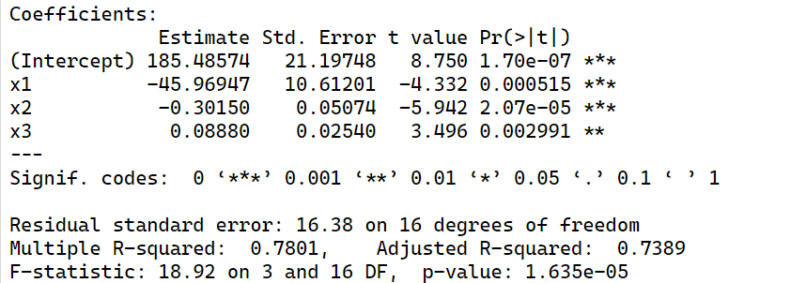

d)
Student’s test:
H0: ${\hat{β}}_{3}=0$
H1: ${\hat{β}}_{3}≠0$
When H0 is true, p-value = 0.002991 < 0.01 -> Reject H0 -> x3 provides useful information about y.

e)
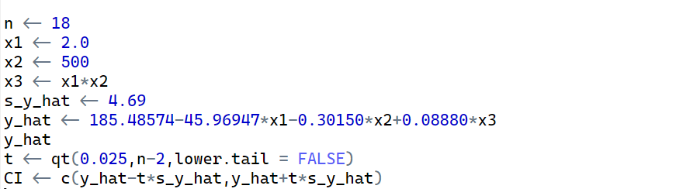

95% CI for the mean value of surface are: (21.65444;41.53916)

